Nimsitha D.M.H

Lab_05

Exercise

1)

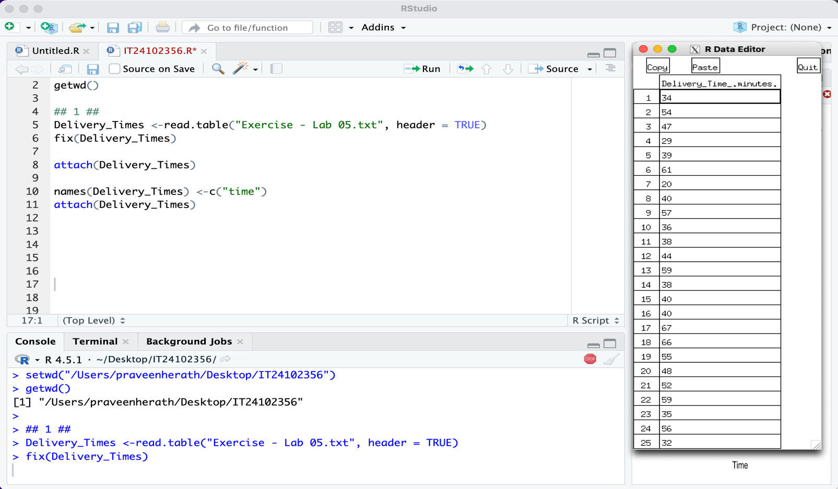

2)

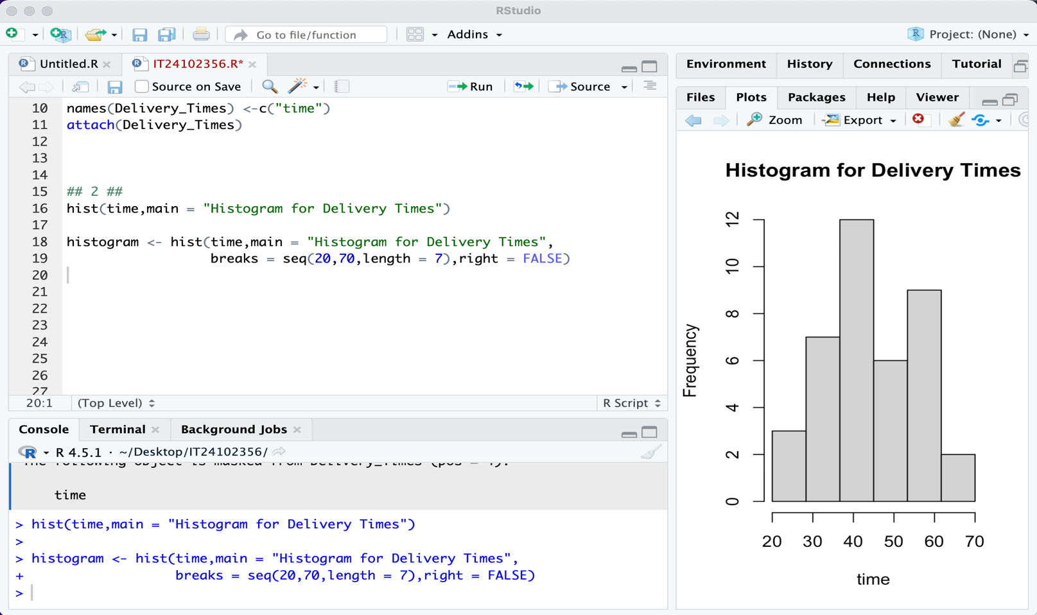

3)

The histogram of delivery times shows that most delivery times fall in the middle range (around 40–55 minutes), and the shape is approximately symmetric, close to a bell-shaped distribution.

4)

